Exercise
- Number Checker:
- Write a script named num_check.sh that takes one number as an argument.
- The script should use an if...elif...else statement to print whether the number is positive, negative, or zero.
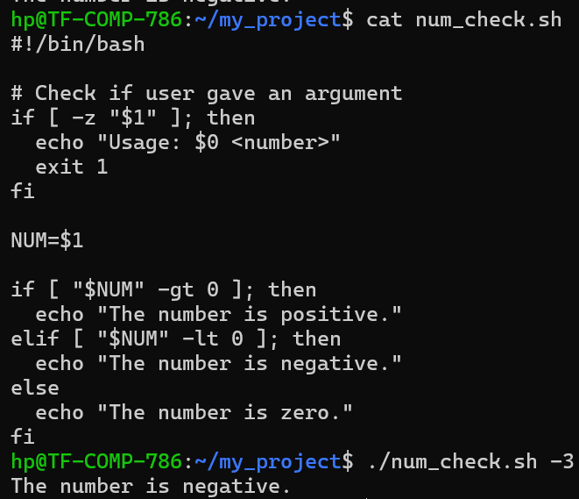
- File Inspector:
- Write a script named file_info.sh that takes one argument (a name of something in the current directory).
- The script should use if and file operators (-f, -d) to check and print whether the argument is a regular file, a directory, or does not exist.
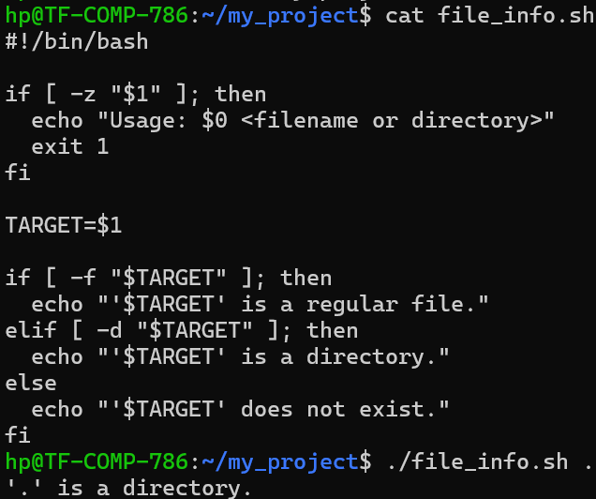
- Simple Animal Facts:
- Write a script named facts.sh that accepts one argument: "cat", "dog", or "bird".
- Use a case statement to print a simple fact for the given animal. Include a default case for any other input.
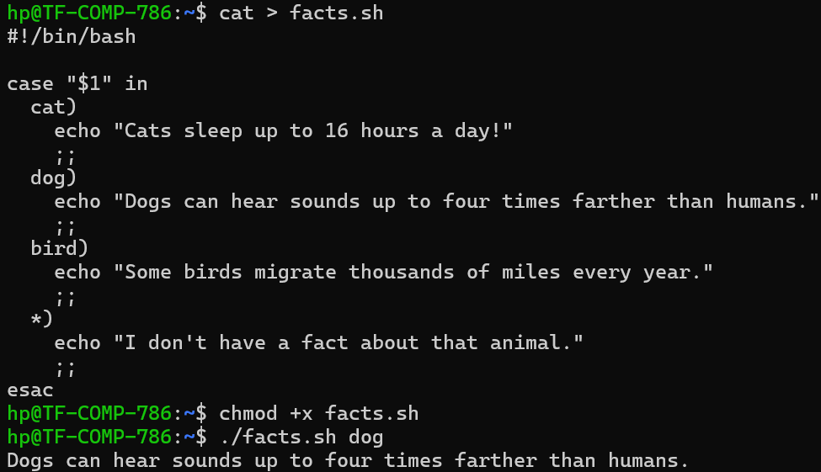
- Countdown Timer:
- Write a script named countdown.sh that uses a C-style for loop to count down from 10 to 1, printing each number. After the loop, it should print "Liftoff!".
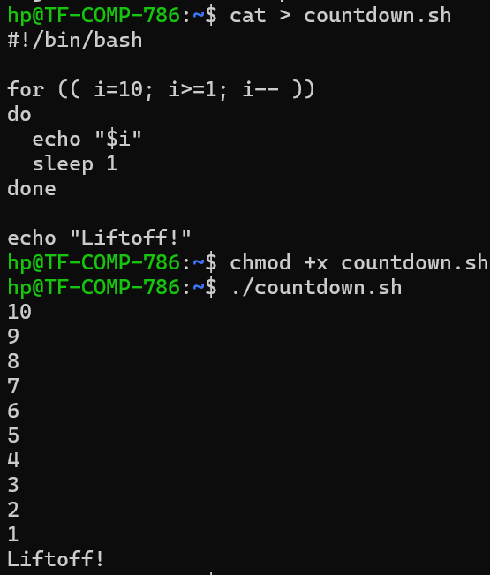
- Summation Calculator:
- Write a script named sum.sh that takes one number as an argument.
- Using a while loop and the $((...)) syntax for arithmetic, calculate and print the sum of all integers from 1 up to that number. (e.g., if the input is 5, the output should be 15, which is 1+2+3+4+5).
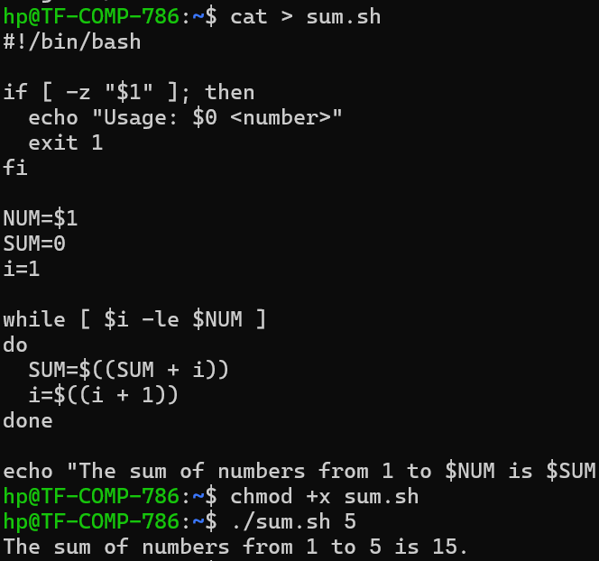\
- Greeting Function:
- Write a script named greeter.sh that defines a function called say_hello.
- The function should take one argument (a name) and print "Welcome to the team,[name]!".
- Call the function three times from within the script, with three different names.
